Q1: At the pdf document on the dropbox link (the first paragraph of page 20), it is mentioned about existing customers would pay more expensive for the company's service after a certain point, because the company has a higher promotion cost for acquisition. I have also an experience some brands. Could we say that higher prices applied to old customers may cause loss of them?

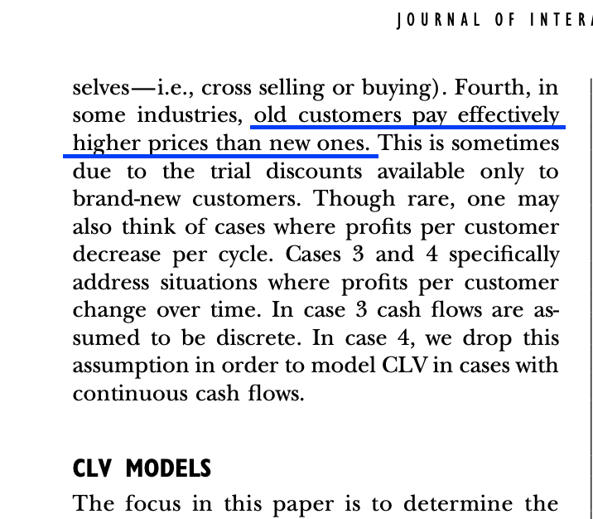

Q2: On the DataCamp chapter at 2:56, it is understood that customer lifetime value is calculated yearly, and companies act according to this calculation. when an extraordinary situation which affects the company's sales occurs, how can we interpret customer lifetime value calculation? for example, the pandemic has affected several sectors harshly, and this ongoing.

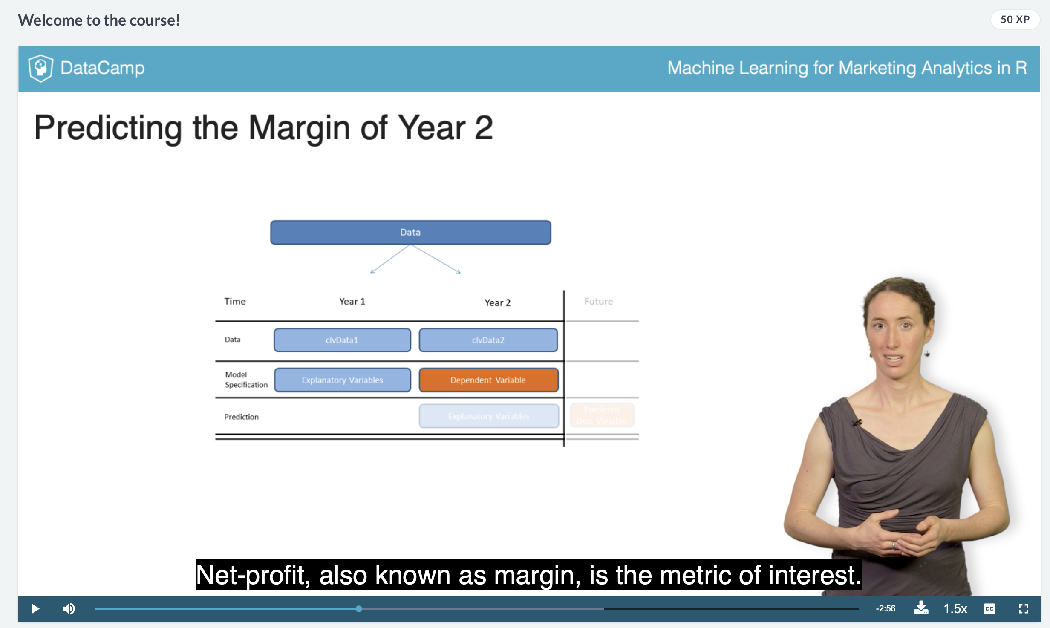

Q3: At the pdf document on the dropbox link (the figure above page 29), can we say a higher acquisition cost causes lower retention rates?

